Report 3

before my test data was giving a higher accuracy than my training data:

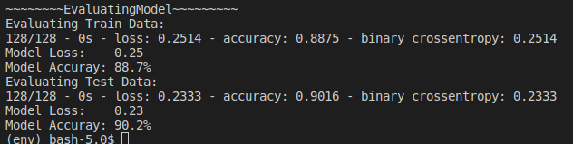

After by adding weight regulation and dropout rate I dont get overfitting where the training data accuracy is lower than the test data accuracy:
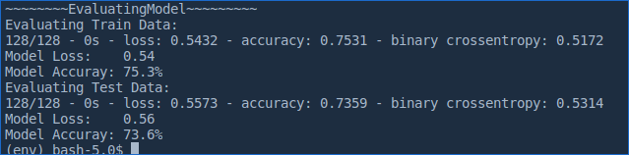

What I decided to do was add in a learning rate that had a decay. Next what I did was add the weights. The weight number was set to 64 because I though this was a medium model just looking at the csv inputs. Dropout rate was added to prevent overfitting.

To run in CMD: python CHDModel.py

NOTE: when running this line above that the heart_test and the heart_train csv’s must be in the same folder as this python code

